Programing Project – Task 2

Analysis

I am programing a two-player dice game, in which the players roll 2 six-sided dice and collect points depending on the roll. They’re 5 rounds in a game. After a player has won, the user needs to submit their name and score into a leader board that is then later saved into a text file. In addition to that, only authorized users are allowed to play the game.

I am programing with legal issues in mind by coding with privacy in mind and not collecting any user data or information during runtime of the program unless consent is given. Cultural issues will be in mind by not using cursive and / or offensive language in the program also any colour schemes I use in the designing of my program will not offend off anyone in any given country. Lastly, I will consider environmental values by distributing this program digitally so there is no wasted discs when people don’t want the program anymore.

I will abide to the respective laws including the Data Protection Act 1998 and the Computer Misuse Act 1990.

Design

*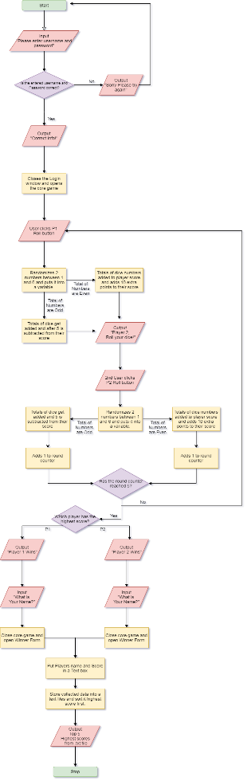Original Size*

*Version on last page*

Development

Testing & evaluation